SQL Project Completed: Blinkit Sales Analysis
Business Problems & Analysis Objectives
Project Overview
Blinkit aims to understand its sales performance, customer preferences, and outlet effectiveness by analyzing transactional sales data. The objective of this project is to use SQL to transform raw sales data into actionable business insights that support strategic decision-making.

1. Total Sales by Fat Content
Business Problem
Management wants to understand whether customers prefer Low Fat or Regular products and determine which category generates the highest revenue.
Objective
Analyze total sales generated by each fat content category to identify customer preferences and support product inventory planning.

2. Total Sales by Item Type
Business Problem
Different product categories contribute differently to overall revenue, but management lacks visibility into top-performing item types.
Objective
Identify which item categories generate the highest sales and determine key revenue-driving products.

3. Fat Content by Outlet for Total Sales
Business Problem
Customer purchasing behavior may vary across outlet types and locations. Management wants to understand how fat content preferences differ by outlet.
Objective
Compare sales performance of Low Fat and Regular products across different outlets to identify sales patterns.

4. Total Sales by Outlet Establishment Year
Business Problem
The company wants to evaluate whether older or newer outlets perform better in terms of revenue generation.
Objective
Analyze sales performance based on outlet establishment year and identify long-term outlet trends.

5. Percentage of Sales by Outlet Size
Business Problem
Management needs to understand how outlet size impacts sales contribution and whether larger stores generate proportionally higher revenue.
Objective
Calculate sales contribution percentages for Small, Medium, and High-sized outlets.

6. Sales by Outlet Location
Business Problem
Different geographic locations may contribute differently to business performance. The company wants to identify high-performing regions.
Objective
Evaluate sales across Tier 1, Tier 2, and Tier 3 locations to determine which markets drive the most revenue.

7. All Performance Metrics by Outlet Type
Business Problem
Management requires a complete performance comparison across outlet types to identify operational strengths and weaknesses.
Objective
Measure and compare:
- Total Sales
- Average Sales
- Number of Items Sold
- Average Customer Rating
for each outlet type to evaluate overall business performance.

Expected Business Outcomes
Through this analysis, Blinkit can:
- Identify top-performing products and categories.
- Understand customer purchasing preferences.
- Evaluate outlet performance and efficiency.
- Optimize inventory planning.
- Improve revenue generation strategies.
- Support data-driven business decision making.

Answers
KPI’s
1. Total Sales
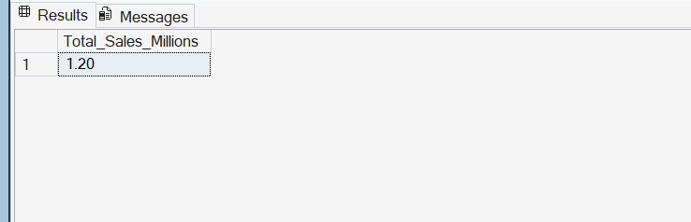
2. Avg Sales
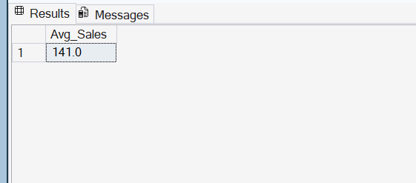
3. No Of Items
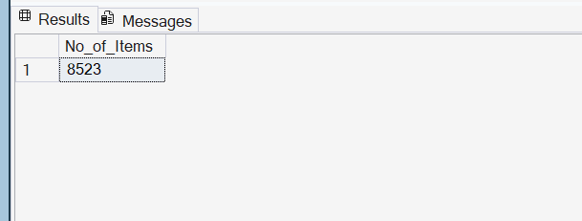

4. Avg Rating
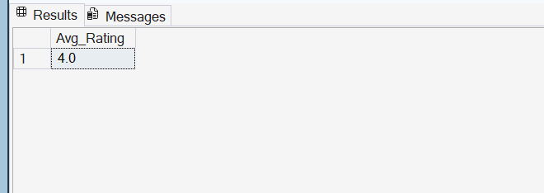
Business Requirements
1. Total Sales by Fat Content
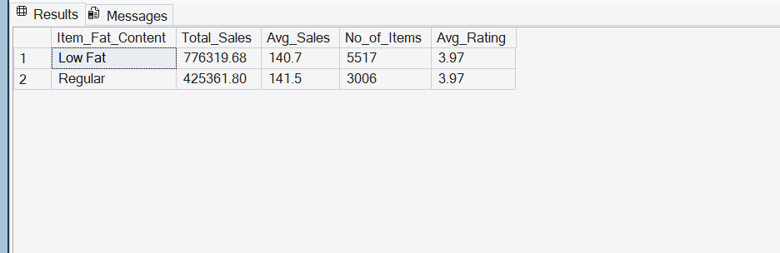
2. Total Sales by Item Type
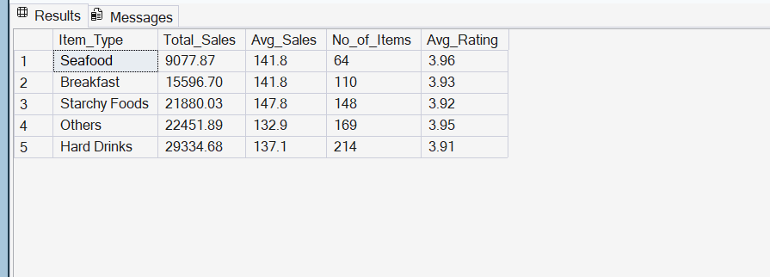
3. Fat Content by Outlet for Total Sales
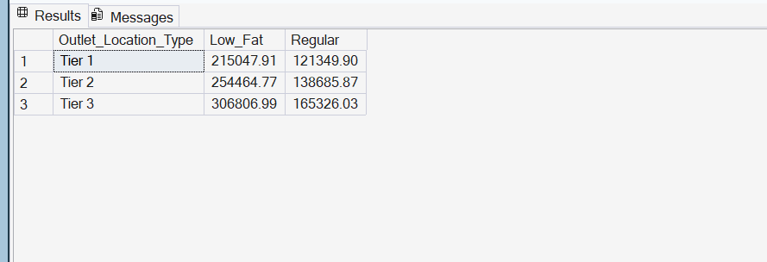

4. Total Sales by Outlet Establishment
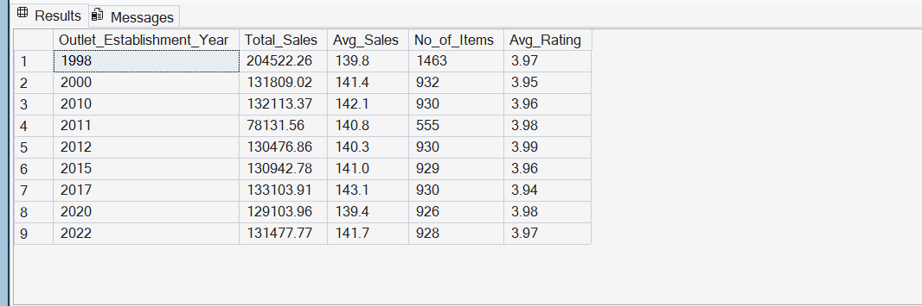
5. Percentage of Sales by Outlet Size
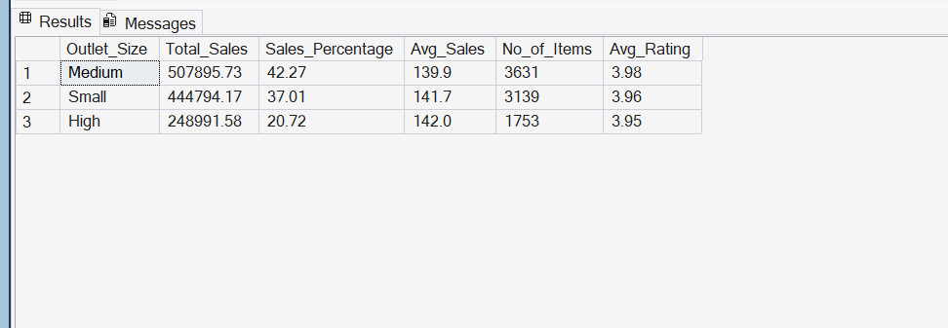
6. Sales by Outlet Location
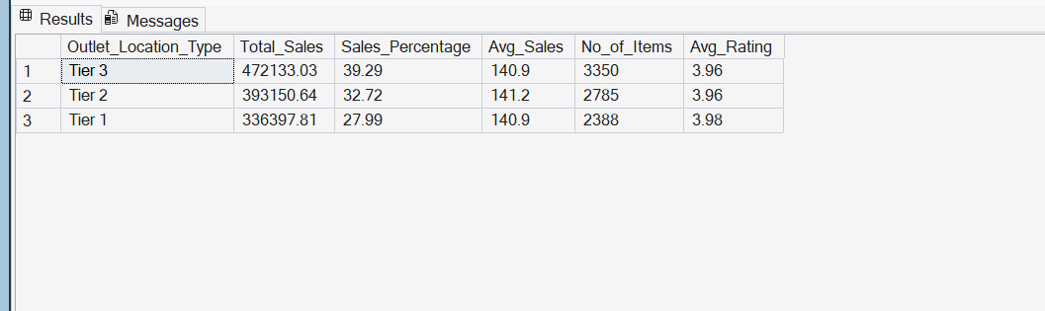

7. All Metrics by Outlet Type
